Skudonet Error

- We have a cluster with these components:
Master IP: 10.7.3.147
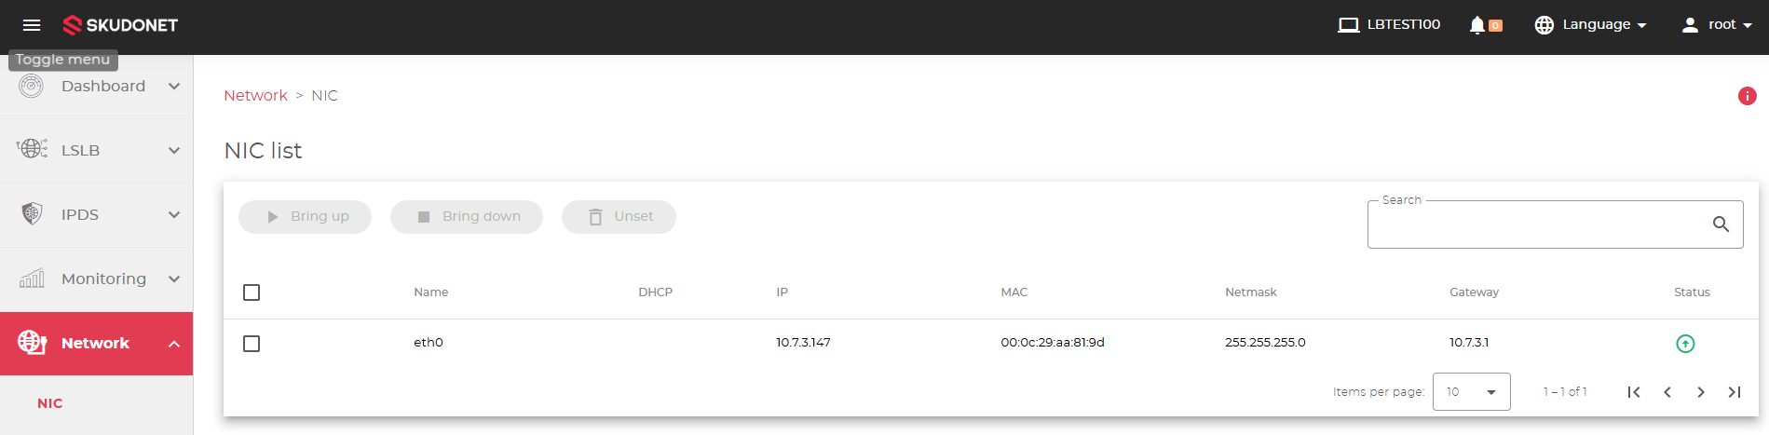

Backup IP: 10.7.3.148
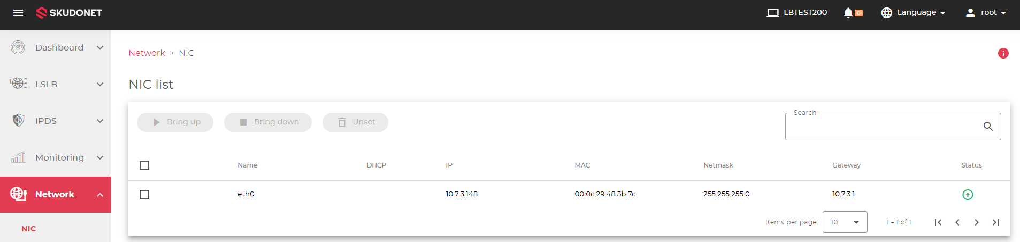

Cluster IP: 10.7.3.149
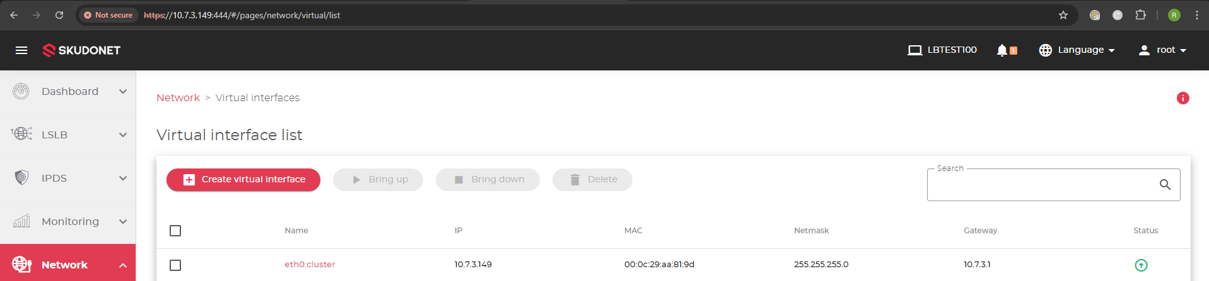

We have created 6 virtual interfaces and all of them are up, as you can see in this images the master node is LBTEST100.
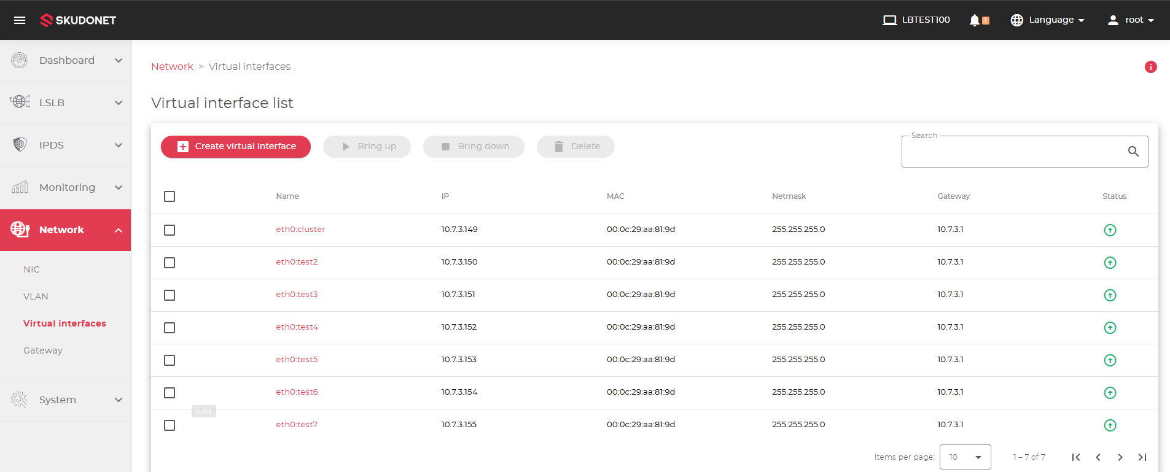

If we ping to those Vitual Interfaces, they respond without issues
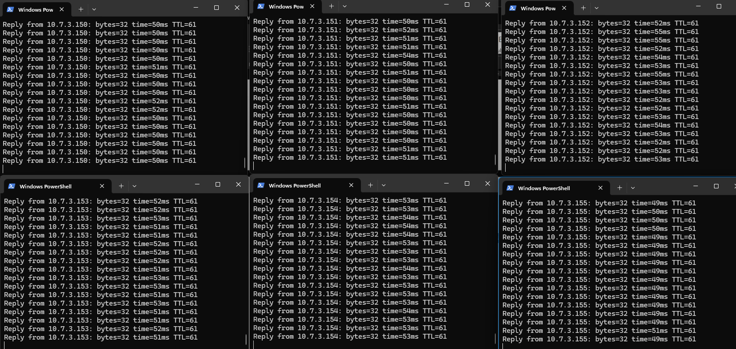

So far everything seems to be working, but as soon as we made the failover the virtual interfaces stopped responding, but in the LB, they seemed to be up, though.
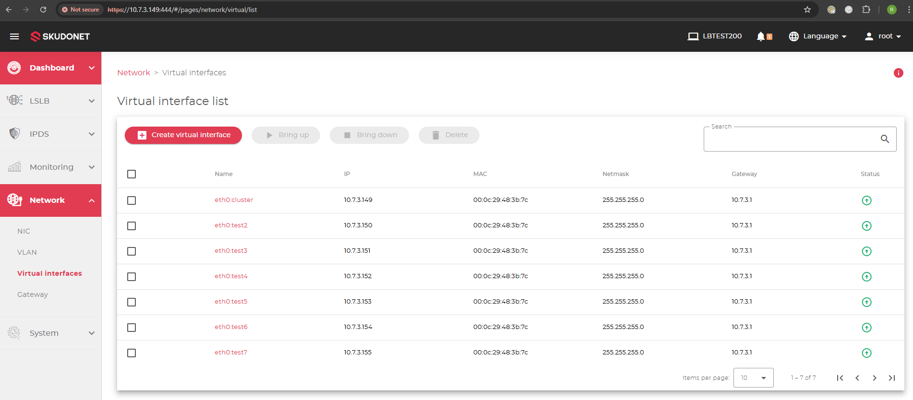
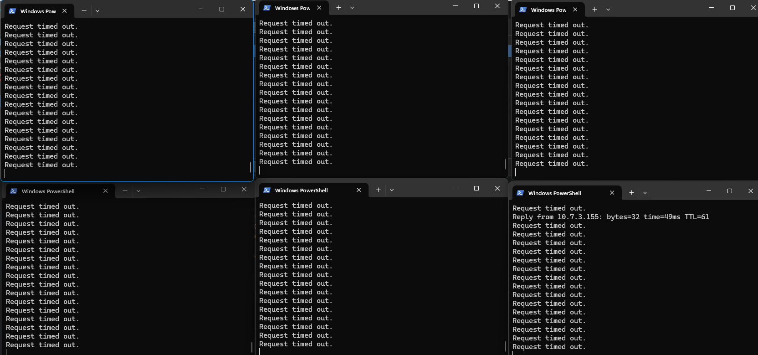

We run the commands you sent us, and these are the results.
